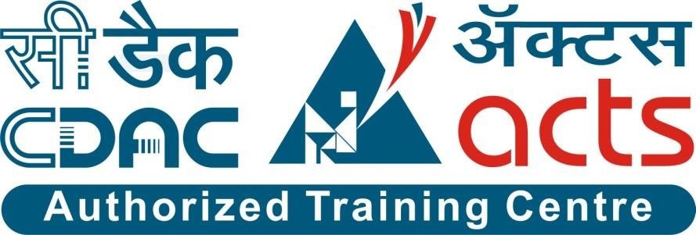

Project Name: Wander Logix Travel Management System

Branch DAC Mar-2024

Documentation On

**“WANDERLOGIX TRAVEL MANAGEMENT SYSTEM”**

DAC MAR 2024

**Guided By: Snehal Somvanshi**

Submitted By :

**Group No: 08**

**Abhay Tiwari 240343020002**

**Krushna Bhot 240343020023**

**Dipak Koli 240343020034**

**Prathmesh Bhendarkar 240343020074**

# Table of Contents

1. Introduction .......................................................................................................................... 4
   1. Document Purpose .......................................................................................................... 4
   2. Project Background ..........................................................................................................4
   3. Aim & Objectives ............................................................................................................4
2. Business Requirements Overview………...…………………………………………...……5

3.Functional Requirements ......................................................................................................5

* 1. Admin Module ................................................................................................................5
  2. Customer Module ............................................................................................................6
  3. Tour Manager Module ....................................................................................................6
  4. Tour Guide Module…………………………………..…………………………………6

1. Non-Functional Requirement……...…………………………………………………….…7

1. Use Case Diagram ................................................................................................................8
   1. Admin .............................................................................................................................8
   2. Customer…….................................................................................................................9
   3. Tour Manager ................................................................................................................ 10
   4. Tour Guide……………………………………………………………………..….…11

## 5.5 Project Architecture Diagram ………….………..…………………………………….….…12

1. Database Design .............................................................................................................. 13
   1. Role .............……....................................…............................................................ 13
   2. User………….......................................................................................................... 13
   3. Tour Member …………………………………….………………….………...…...13
   4. Tour Package.............................................................…............................................14
   5. Tour Payment ...................................................................................................……14
   6. Tour Transactions ................................................................................................…15
   7. Tour Image ..........................................................................................................…15

## 8. E-R Diagram…………………………………………………………………………………….16

1. Snapshots ..................................................................................................................…17
2. Conclusion and Future scope ....................................................................................…27

**List of Figures**

Use Case Diagrams ............................................................................................................. 17

Fig 1 Project Architecture ……………………………………………………….………...13

Fig 2 Admin ....................................................................................................................…. 9

Fig 3 Customer ............................................................................................................….... 10

Fig 4 Tour Manager ........................................................................................................... 11

Fig 5 Tour Guide ................................................................................................................ 12

Fig 6 ER Diagram .............................................................................................................. 16

1. **Introduction:**

* 1. **Document Purpose:**

This document communicates the business requirements and scope for developing WanderLogix Travel Management System. The scope of this document is to define the functional and non functional requirements, business rules and other constraints requirements.

* 1. **Project Background:**

The travel industry is experiencing rapid growth and diversification, but many travel agencies still rely on outdated, manual processes for booking and managing tours. These manual processes lead to inefficiencies, errors, and delays, negatively impacting customer satisfaction and business profitability. The WanderLogix Travel Management System aims to revolutionize the travel booking and management landscape by introducing a comprehensive, automated solution that enhances operational efficiency and customer experience. This system will enable businesses to offer a variety of predefined travel packages tailored to different cities, while also providing the flexibility to customize activities, itineraries, and other travel components to meet specific customer needs.

* 1. **Aim & Objectives:**

The primary goal of the WanderLogix Travel Management System is to create an innovative platform that streamlines the entire travel booking and management process, thereby increasing operational efficiency, reducing errors, and enhancing customer satisfaction. Key objectives include:

* Developing a user-friendly interface that simplifies the booking process for customers.
* Providing a robust back-end system for administrators and tour managers to manage travel packages, customer information, and tour details efficiently.
* Offering predefined travel packages for various destinations, with the unique feature of allowing customers to customize activities and itineraries within these packages.
* Implementing automated notifications and real-time updates to keep customers informed about their bookings and tour status.

1. **Business Requirements Overview:**

• **WanderLogix Travel Management System** is a public web application that simplifies booking and managing travel tours.

• **User Types:**

* + - **Customers:** Browse, customize, and book travel packages; manage accounts; view tour details; receive real-time updates.
    - **Service Providers (Tour Managers & Guides):** Create and manage tour packages; update tour status; interact with customers.
    - **System Management:** Admins oversee system operations, enforce policies, and generate reports.
    - **Phased Rollout:** Initially targets specific regions, with plans to expand.

1. **Functional Requirements Overview:**

WanderLogix Travel Management System consists of four modules described as below.

* + - * 1. Admin Module
        2. Customer Module
        3. Tour Manager Module
        4. Tour Guide Module

* 1. **Admin Module**
* The system provides functions for Admin to handle the overall system management.
* Admins can monitor and manage all registered users (customers) and their activities.
* Admins can generate reports on bookings, revenue, and user activity.
* Admins can enforce system policies and guidelines.
* Admin can approve tour plans and creating various instances for different dates

* 1. **Customer Module**

* Customers can register and create their own account.
* The system provides functions that allow customers to browse and book different kinds of travel packages for different cities.
* Customers can view detailed information about tours, including itineraries, pricing, and availability.
* Customers can leave reviews and feedback about their travel experiences.
* The system supports a "Refund and Cancellation Policy" in case of dissatisfaction.
  1. **Tour Manager Module**

* Tour Managers can design and manage the activities and itineraries of tours.
* The system provides functions for creating and updating travel packages (Silver, Gold, and Platinum) for each city.
* Tour Managers can set and adjust pricing and availability for each package.
* Tour Managers can manage detailed descriptions and schedules for each tour.

**3.4 Tour Guide Module**

* Tour Guides can update the status of activities and tours in real-time.
* The system provides functions for Tour Guides to inform customers about the status of activities and any changes.
* Tour Guides can add notes and feedback on the progress and completion of tour activities.

1. **Non-Functional Requirement:**

* The website should use a professional design, look and feel, and color scheme.
* Users will have no limitations for accessing the application through the Internet. The portal being an internet application, it is difficult to specify the exact number of visitors or users. Hence, we will target the system to support between 5 and 10 thousand users on launch of phase 1.
* Being a public website, the site must follow general usability guidelines for menus, navigation, colors, links, and other actions provided on the screens.
* The system should be designed in such a manner that users will be able to complete tasks in a minimum number of steps.
* The system should ensure data security and privacy for all users.
* The system should be scalable to accommodate future growth and additional features.

**Use-Case Diagram**

**5.1 Admin:**

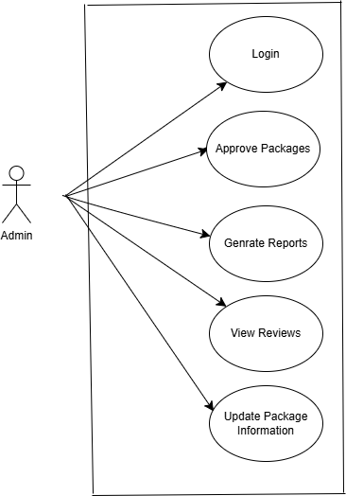

Fig. Use-Case Diagram for Admin

* 1. **Customer:**

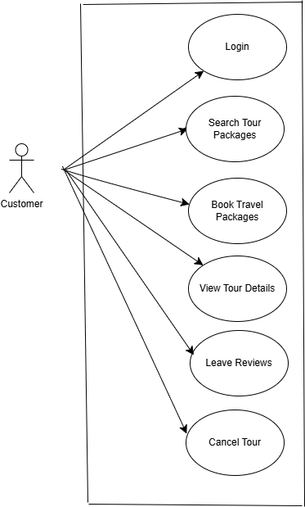

Fig. Use-Case Diagram for Customer

* 1. **Tour Manager:**

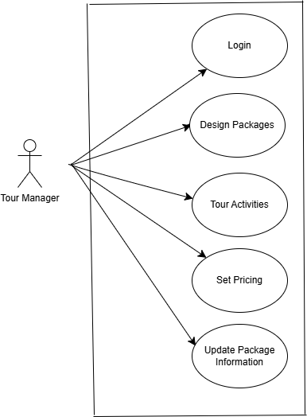

Fig. Use-Case Diagram for Tour Manager

* 1. **Tour Guide:**

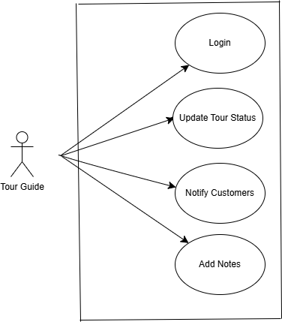

Fig. Use-Case Diagram for Tour Manager

**6.Project Architecture Diagram:**

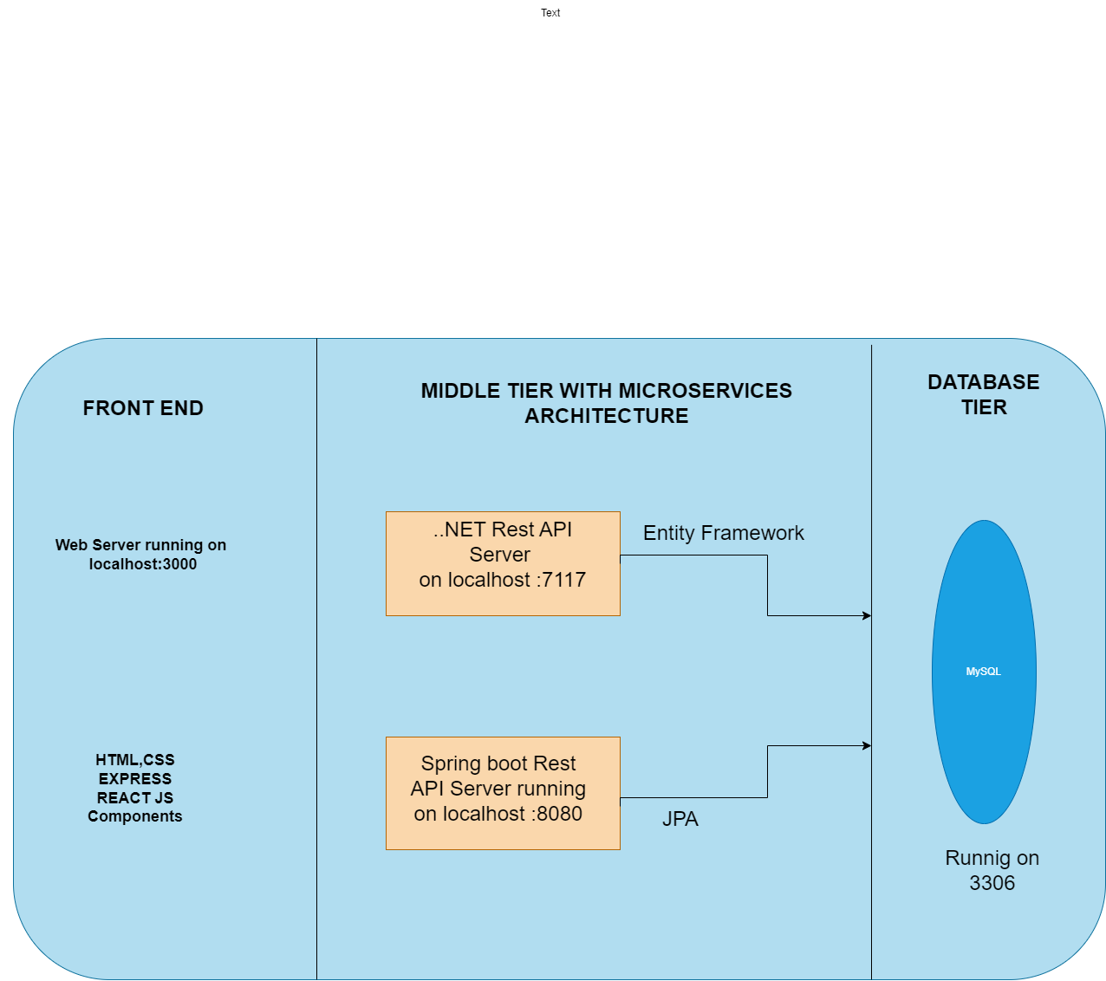

## Fig. Project Architecture Diagram

**7. Database Design:**

1. **Role table:**

|  |  |  |  |  |  |
| --- | --- | --- | --- | --- | --- |
| **Field** | **Type** | **Null** | **Key** | **Default** | **Description** |
| Role_id | Integer |  | Primary Key | Null | Unique role ID |
| Role_name | Varchar(30) |  |  | Null | Role of customer |

1. **User table:**

|  |  |  |  |  |  |
| --- | --- | --- | --- | --- | --- |
| **Field** | **Type** | **Null** | **Key** | **Default** | **Description** |
| User_id | Integer |  | Primary key | Null | Unique ID of user |
| fname | Varchar(15) |  |  | Null | First name of user |
| sname | Varchar(15) |  |  | Null | Last name of user |
| email | Varchar(30) |  |  | Null | Email of user |
| password | Varchar(400) |  |  | Null | Password of user |
| Phone_no | Integer |  |  | Null | Phone no of user |
| Address | Varchar(50) |  |  | Null | Address of user |
| Aaadhar no | Integer |  |  | Null | Unique ID of user |
| Role_id | Integer |  | Foreign key | Null | Role_id |

**3.Tour Member table:**

|  |  |  |  |  |  |
| --- | --- | --- | --- | --- | --- |
| **Field** | **Type** | **Null** | **Key** | **Default** | **Description** |
| Member_id | Integer |  | Primary key | Null | Unique ID of the tour member |
| User_id | Integer |  | Foreign key | Null | Unique id of the user |
| tt_id | Integer |  | Foreign key | Null | Unique id of tour transaction |
| Fname | Varchar(15) |  |  | Null | First name of member |
| lname | Varchar(15) |  |  | Null | Last name of tour member |
| Aadhar_no | Integer |  |  | Null | Unique ID of the tour member |

**4. Tour Package table:**

|  |  |  |  |  |  |
| --- | --- | --- | --- | --- | --- |
| **Field** | **Type** | **Null** | **Key** | **Default** | **Description** |
| Tour package id | Integer |  | Primary key | Null | Tour package ID |
| Tour name | Varchar(45) |  |  | Null | Name of tour |
| Description | Varchar(250) |  |  | Null | Respective tour information |
| Price | Double |  |  | Null | Price of tour package |
| Start_date | Date |  |  | Null | Start date of tour |
| End date | Date |  |  | Null | End date of tour |
| Duration | Integer |  |  | Null | Duration of tour |
| No of seats | Integer |  |  | Null | No of seats in a tour |
| Status | Varchar(20) |  |  | Null | Status of the tour |
| Mgr id | Integer |  | Foreign key | Null | Manager id |
| Guide id | Integer |  | Foreign key | Null | Guide id |

**5.Tour Payment table :**

|  |  |  |  |  |  |
| --- | --- | --- | --- | --- | --- |
| **Field** | **Type** | **Null** | **Key** | **Default** | **Description** |
| Payment id | Integer |  | Primary key | Null | Unique ID generated by payment |
| Tour transaction id | Integer |  | Foreign key | Null | Tour transaction id |
| Amount | Double |  |  | Null | Price of the package |
| Payment date | Date |  |  | Null | Date of payment |
| Payment mode | Varchar(15) |  |  | Null | Mode of the payment |

**6.Tour Transactions table:**

|  |  |  |  |  |  |
| --- | --- | --- | --- | --- | --- |
| **Field** | **Type** | **Null** | **Key** | **Default** | **Description** |
| Tour transaction id | Integer |  | Primary key | Null | Unique ID of transaction |
| Status | Varchar(30) |  |  | Null | Status of tour |
| Booking date | Datetime |  |  | Null | Date of the tour |
| User id | Integer |  | Foreign key | Null | Unique id of user |
| Tour package id | Integer |  | Foreign key | Null | Unique package ID |

**7.Tour Image table:**

|  |  |  |  |  |  |
| --- | --- | --- | --- | --- | --- |
| **Field** | **Type** | **Null** | **Key** | **Default** | **Description** |
| Image id | Integer |  | Primary key | Null | Unique image ID |
| Tp_id | Integer |  | Foreign key | Null | Tour package id |
| Image url | Mediumtext |  |  | Null | URL of Image |

**8. ER-Diagram:**

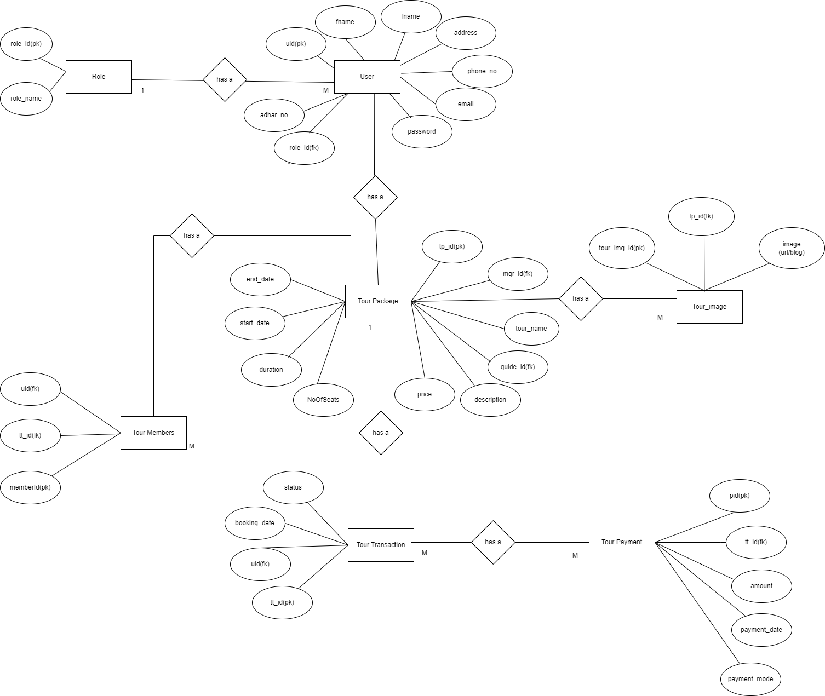

## 

**9. Snapshots:**

**9.1 Home Page:**

Following snapshot shows the Home page for WanderLogix Travel Management System

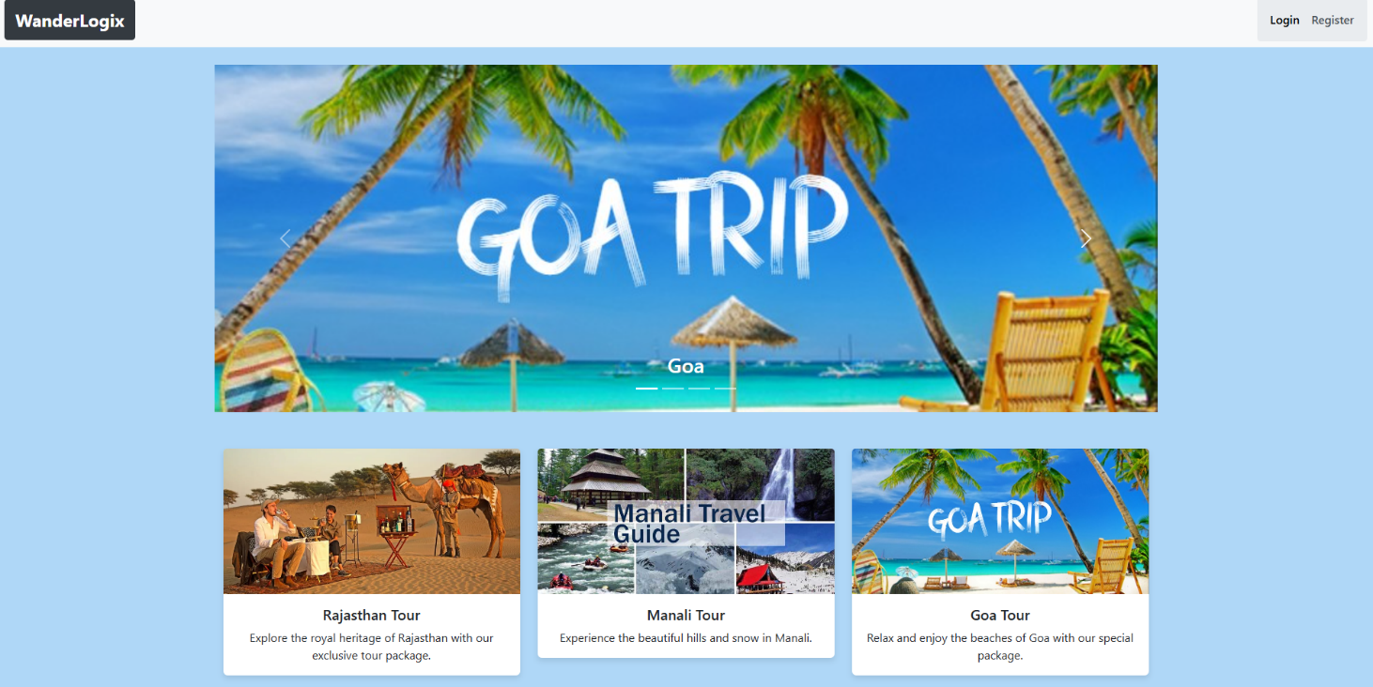

This page contains following controls

* Home
* Login
* Register
* Contact Us

**9.2 Login Page:**

Following snapshot shows the Login page for WanderLogix Travel Management System

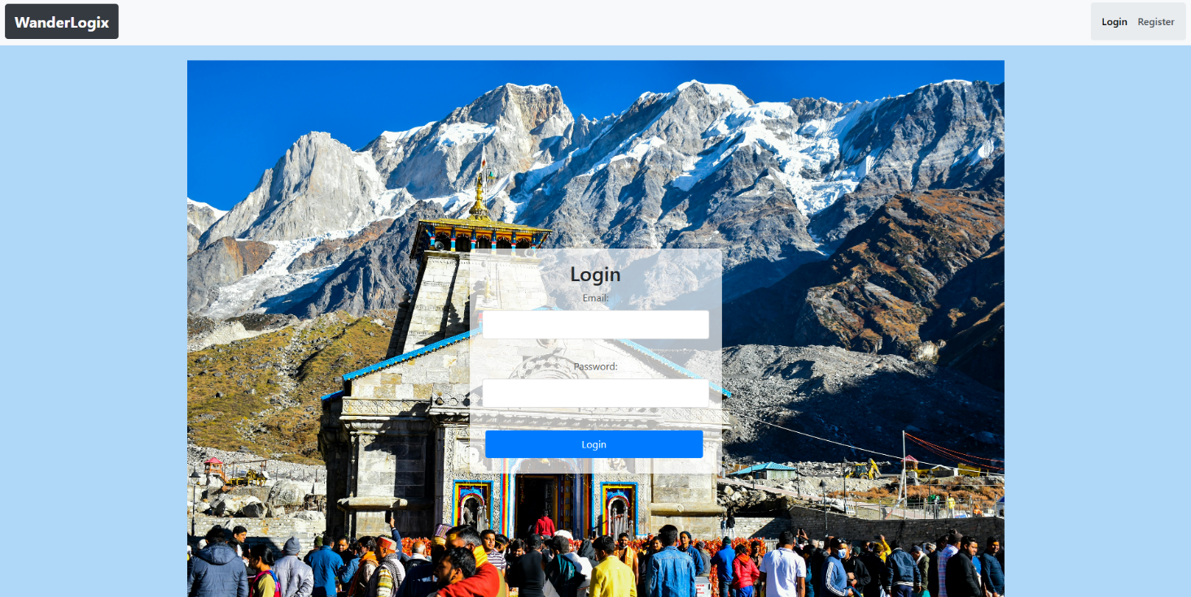

**9.3 Registration Page:**

Following snapshot shows the Registration page for WanderLogix Travel Management System

* User Registration Page:

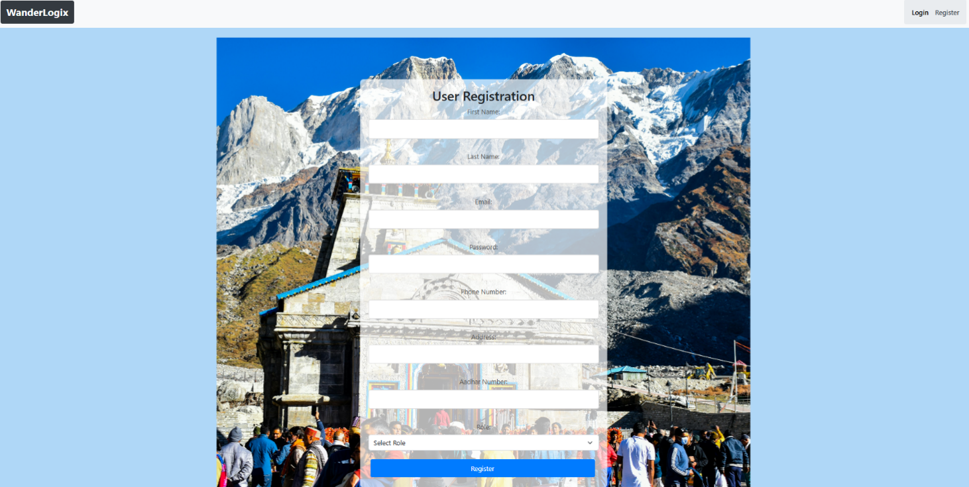

**9.4 Admin Page:**

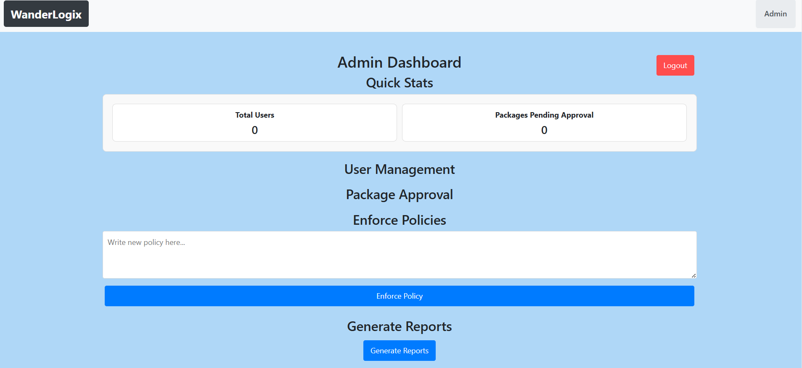

**9.5 Manager Page:**

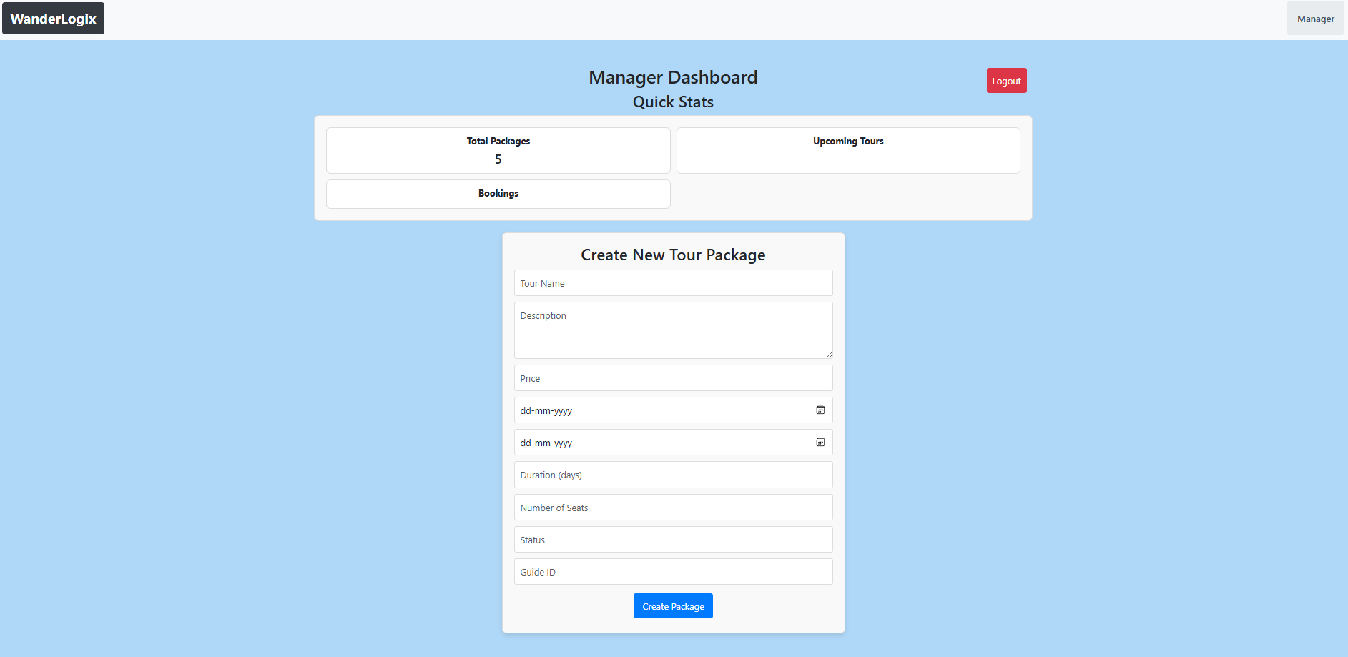

* Create Tour packages Form
* Upcoming Tours

**9.6 Update Tour Package Page:**

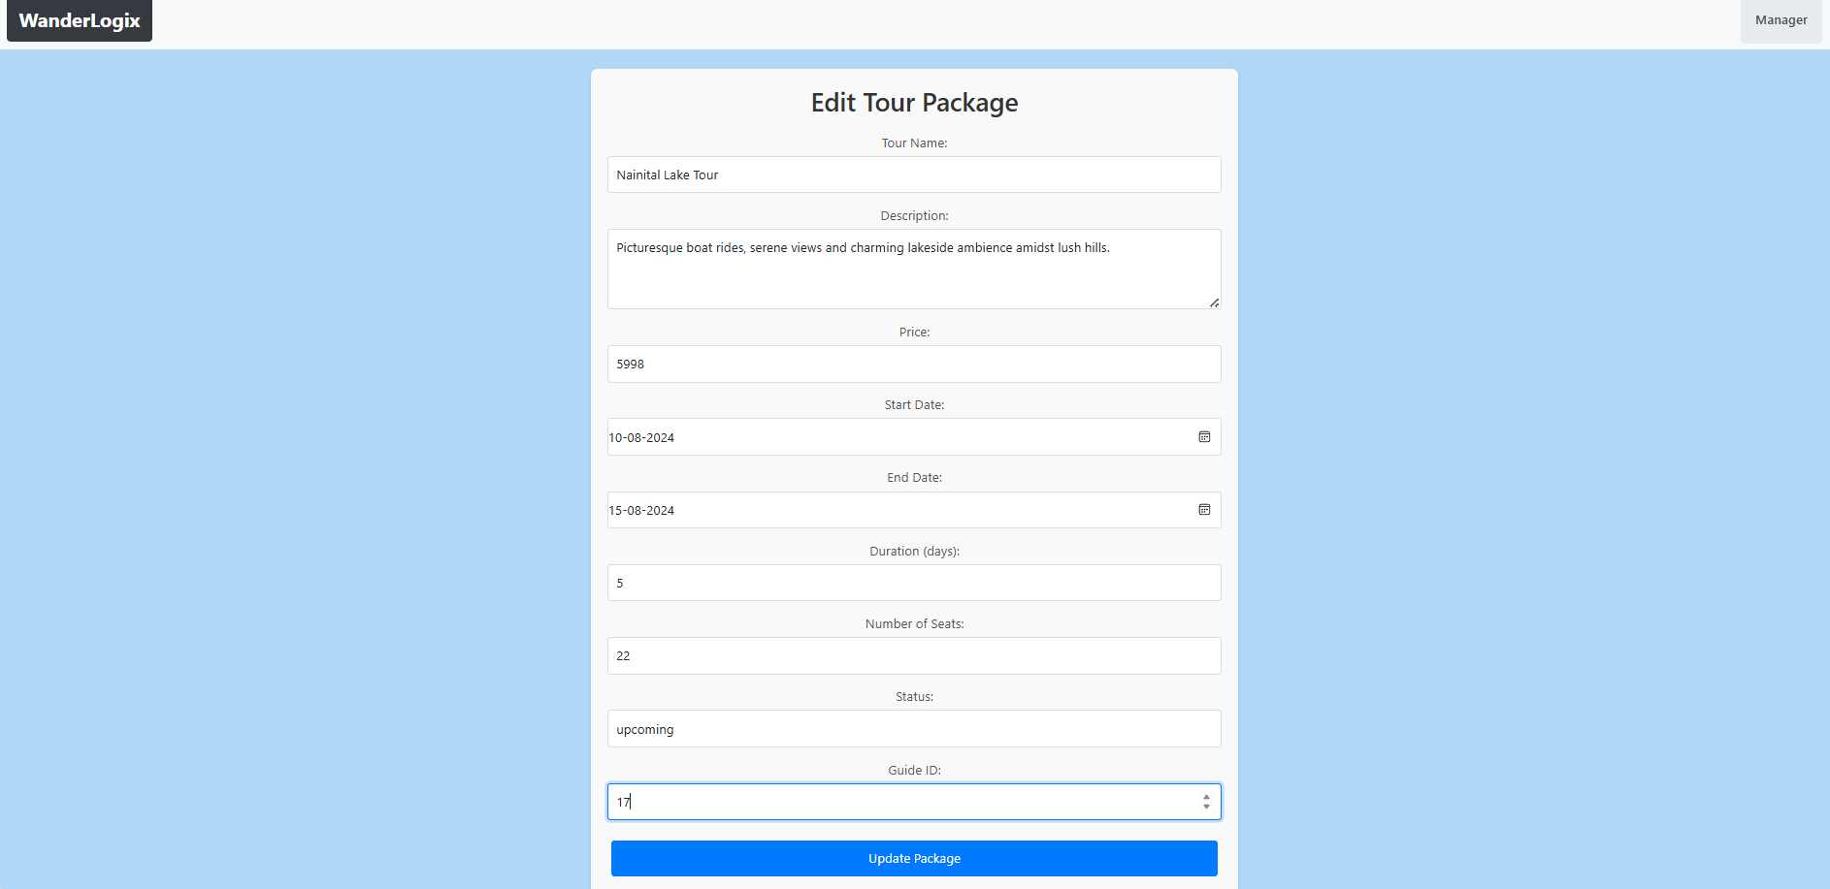

**9.7 Tour Details Package Page:**

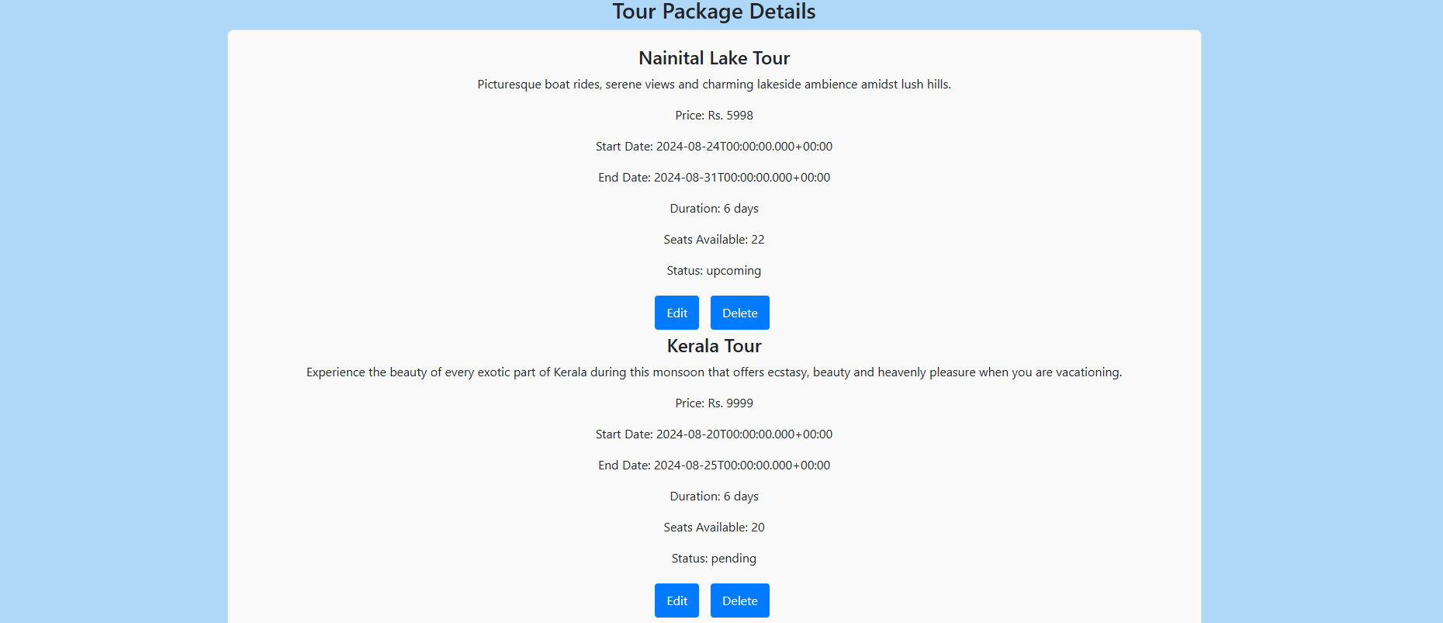

**9.8 Customer Page:**

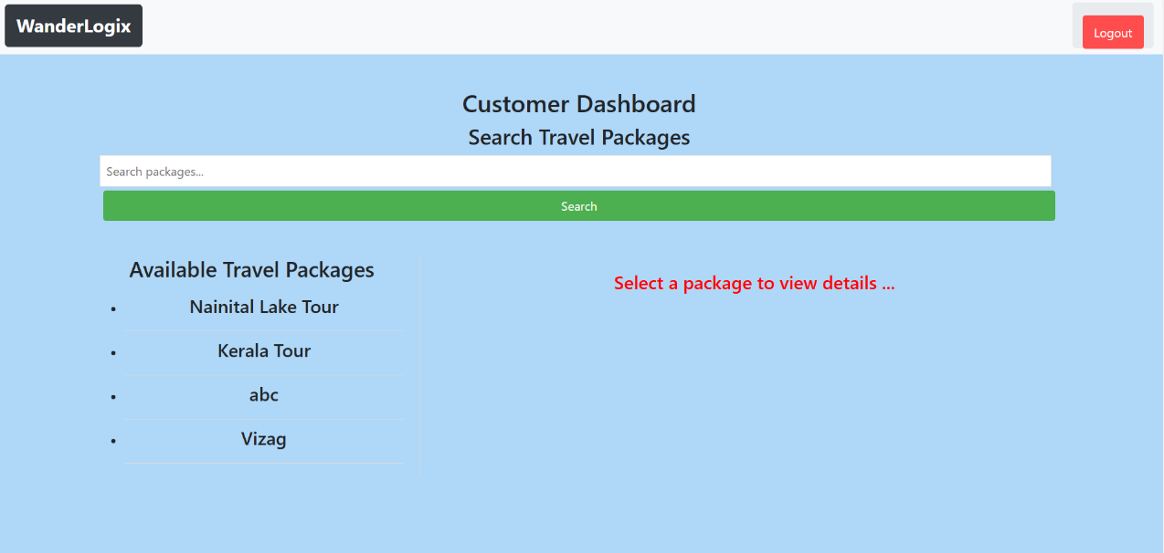

**9.8 Customer Search Tour Package Page:**

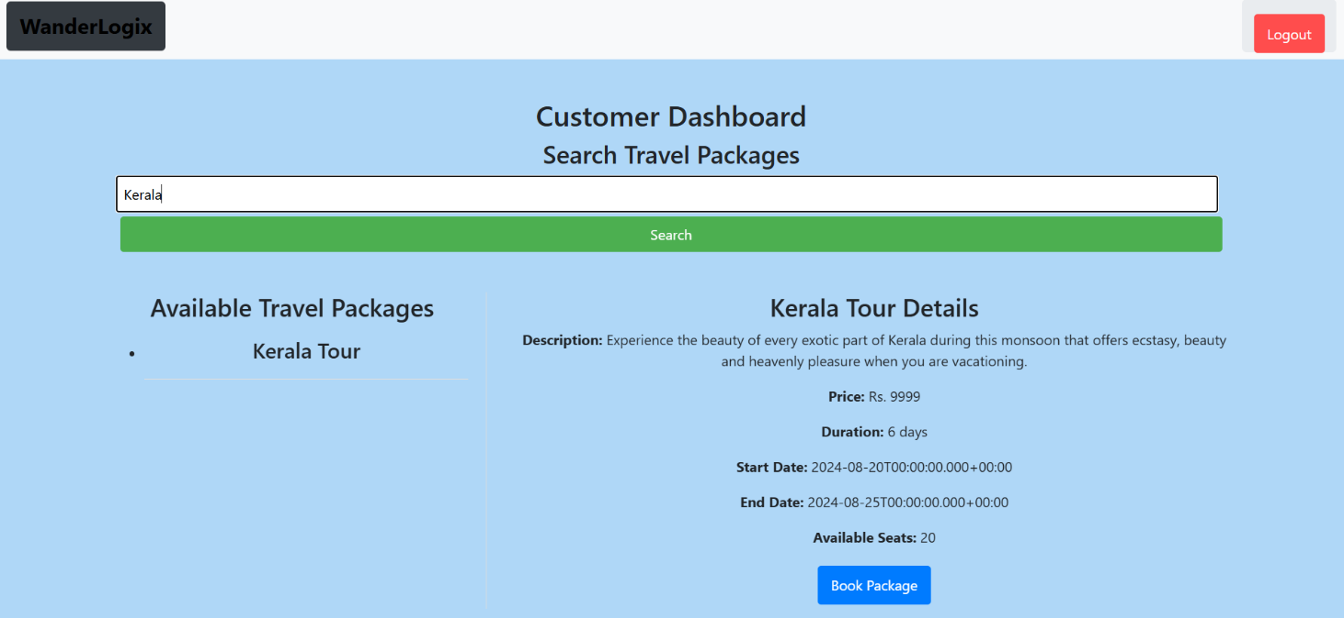

**9.9 Customer Selected Tour Package Detail Page:**

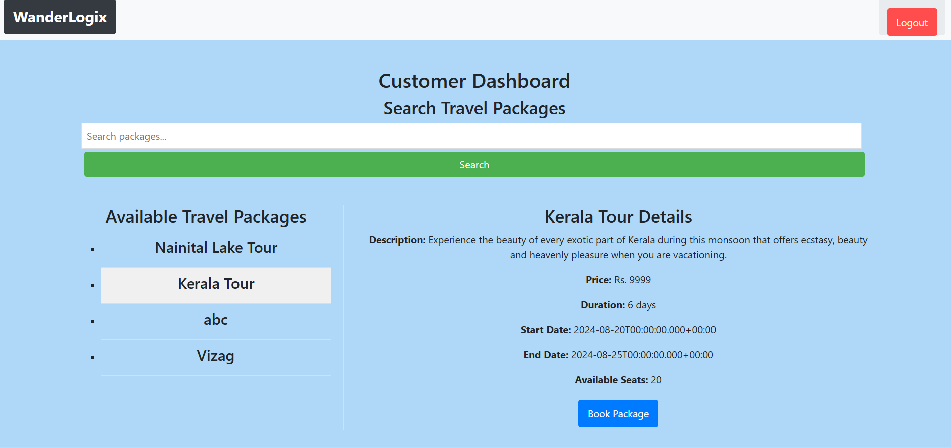

**9.10 Book Package Page:**

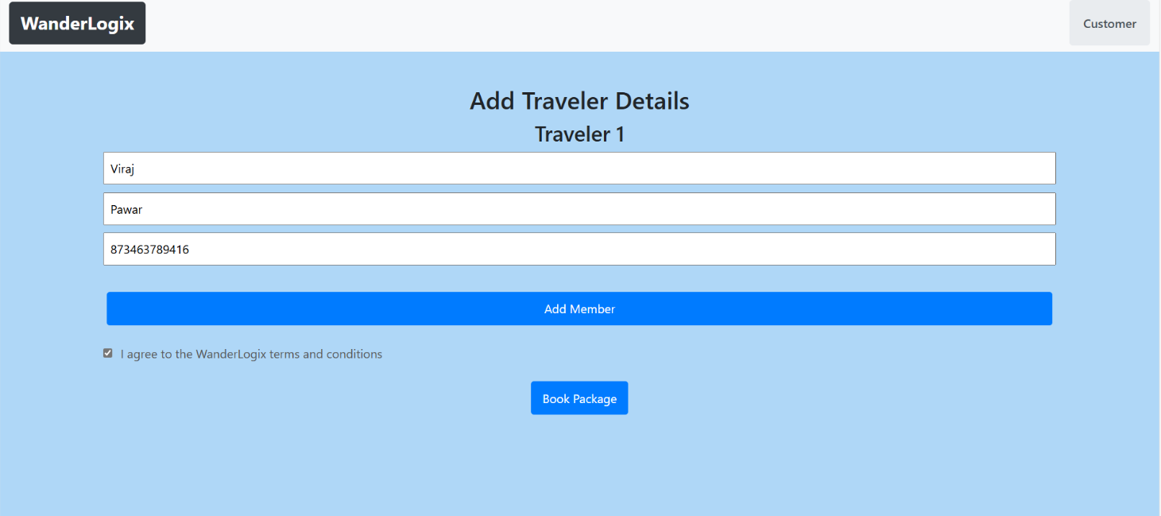

**9.11 Tour Guide Page:**

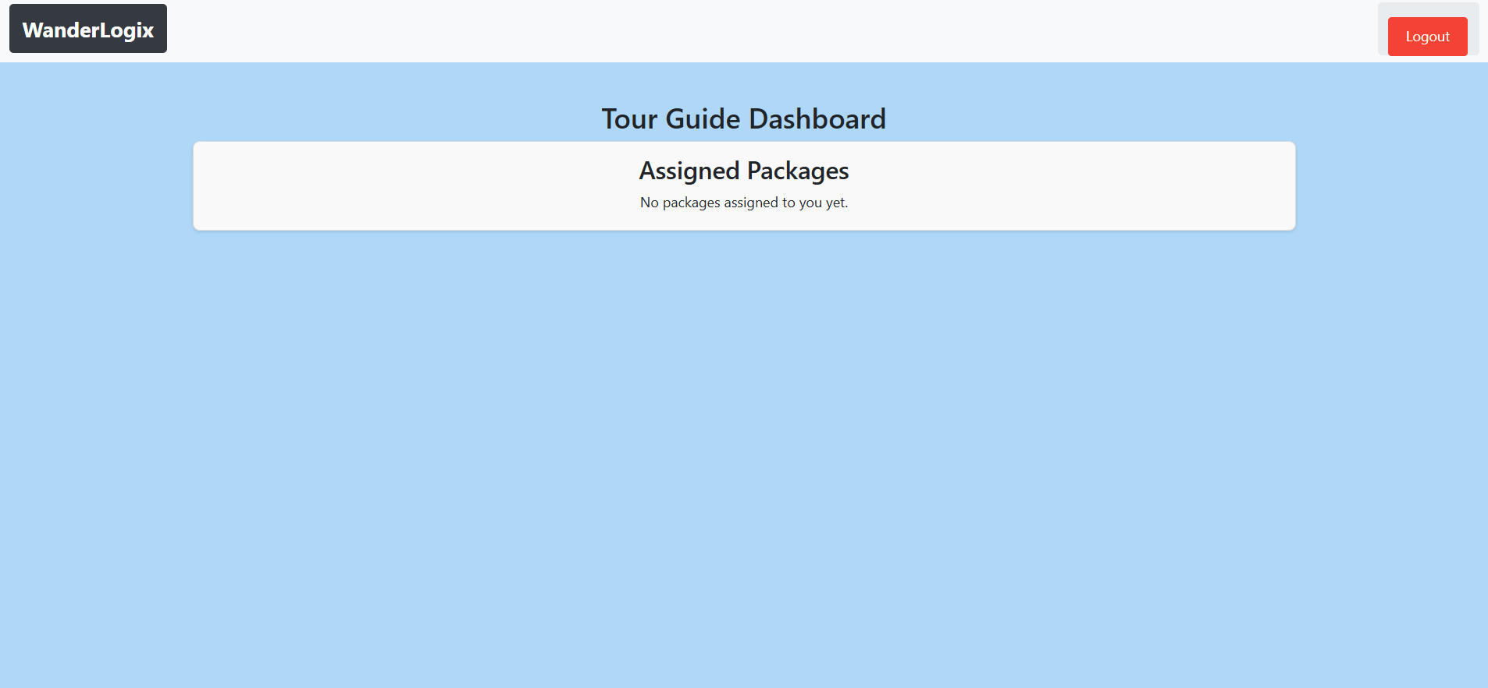

* 1. **CONCLUSION**

The WanderLogix Travel Management System is designed to transform the travel industry by automating and streamlining the booking and management of travel tours. This system addresses the inefficiencies of manual processes that currently hinder travel agencies, offering a comprehensive solution that enhances operational efficiency, reduces errors, and improves customer satisfaction. By providing a user-friendly interface for customers, robust management tools for administrators and tour managers, and real-time updates through tour guides, WanderLogix is poised to become an essential tool for modern travel management.

**11.2FUTURE SCOPE**

The WanderLogix Travel Management System has significant potential for future

enhancements and expansion. Some areas of focus include:

* **Scalability and Growth:** As the system supports more users and expands to new regions, additional features can be integrated, such as advanced analytics, AI-driven travel recommendations, and personalized customer experiences.
* **Enhanced Customization Options:** Future versions of the system could offer more advanced customization options for travel packages, allowing customers to tailor every aspect of their trips, including unique experiences and off-the-beaten-path activities.
* **Global Expansion:** As the system matures, expanding its reach to international markets and adapting the platform to different languages and currencies could significantly broaden its user base.